**Day 7**

**Problem Statement:**

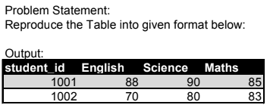

**Solution Code:**

/*Create database ivy_sql_internship*/

create database ivy_sql_internship;

/*Using Ivy sql intership database*/

use ivy_sql_internship;

/*Creating table Marks_Data*/

create table Marks_Data

(student_id int, subjects varchar(100), marks int);

/*Adding value to the table*/

insert into Marks_Data (student_id, subjects, marks)

values

(1001,"English",88),(1001,"Science",90),(1001,"Maths",85),(1002,"English",70),(1002,"Science",80),(1002,"Maths",83);

/*Checking the dataset*/

select * from Marks_Data ;

/*Reproduce the Table into given format below:*/

select student_id,

max(case when subjects = "English" then marks else 0 end) as English,

max(case when subjects = "Science" then marks else 0 end) as Science,

max(case when subjects = "Maths" then marks else 0 end) as Maths

from Marks_Data

group by student_id;

**Screenshot of the Code:**

